Press Contact: Jessica Hird
Email: Jessica@shakespearecenter.org
Phone: (702)807-8411

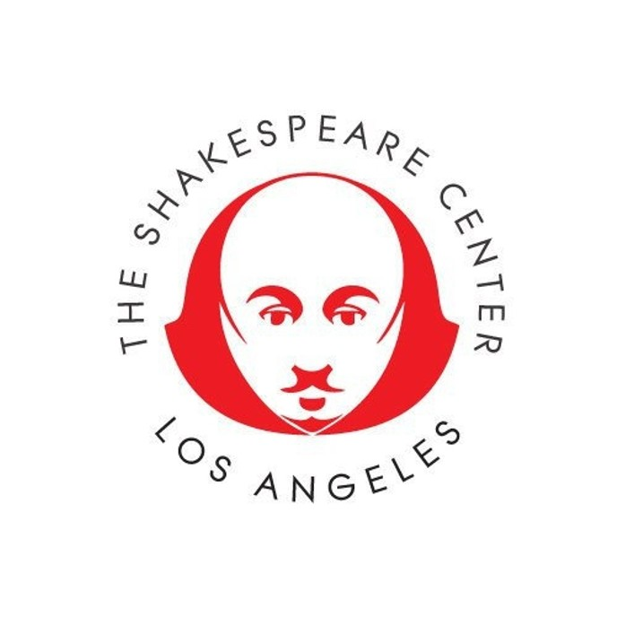

The Shakespeare Center of Los Angeles
presents a benefit staged reading of

William Shakespeare’s
“Love’s Labour’s Lost”
Directed by Louis Fantasia

Followed by the Announcement of Shakespeare Center of Los Angeles’
2019 Summer Shakespeare Production

Sunday, April 28, 2019 at 3 p.m.

The Shakespeare Center of Los Angeles
1238 W. 1st Street, Los Angeles, CA 90026

LOS ANGELES, March 28, 2019 – It’s spring and everyone is in love! What could possibly go wrong? Just ask William Shakespeare, whose Love’s Labour’s Lost, sparkles with wit and romps including love letters delivered to the wrong lovers, Spanish swains, country maids, and really bad love poetry, courtesy of the Bard’s love-blind characters. The Shakespeare Center of Los Angeles (SCLA) presents a staged reading of Shakespeare’s frolicking play Love’s Labour’s Lost on Sunday, April 28th, at 3 p.m. at The Shakespeare Center’s Studio at 1238 West 1st Street, LA, CA 90026 in downtown Los Angeles on the corner of 1st Street and Bixel. The reading of Love’s Labour’s Lost is 90 minutes without an intermission. Tickets are free for SCLA members and start at $30, for general admission, and $40 for VIP, which includes Valet Parking . Tickets are available https://www.shakespearecenter.org/loves-labours-lost-reading

Paid parking lots can be found on Beaudry at the corners of 1st Street, a short walk to The Shakespeare Center of Los Angeles. Street parking is available on the weekends on 2nd Street. Valet parking is reserved for VIP ticket purchasers.

Love’s Labour’s Lost follows the exploits of the young King of Navarre and his three comrades who swear to abstain from wine and women, until they find both. Love’s Labour’s Lost, is directed by Louis Fantasia, a founding director and educator at The Shakespeare Globe Centre in London who has curated and directed SCLA’s BARD READS series of staged readings that have included Antony & Cleopatra (2019), Coriolanus (2018), Titus Andronicus (2018), and Julius Caesar (2018) at City Hall.

The cast of Love’s Labour’s Lost includes Joel Asher (Coriolanus Shakespeare Center of Los Angeles), Ben Atkinson (Coriolanus Shakespeare Center of Los Angeles), Christian Baskous (Richard III NY Shakespeare Festival, The Tempest La Jolla Playhouse), Mark Bramhall (The Merchant of Venice American Conservatory Theatre), Kelsey Deanne, Nora Eschenheimer (As You Like It The Gamm Theatre), Travis Goodman (Cymbeline Will Geer Theatricum Botanicum),
-more-
Atoki Ileka, Daniel Jimenez, Deseree Mee Jung (As You Like It Antaeus Company), Samantha Miller (Comedy of Errors Oregon Shakespeare Festival), Noah Naishtut (Julius Caesar Shakespeare Center of Los Angeles), Michael Naishtut (A Midsummer Night’s Dream Florida Shakespeare Festival), Don Deforest Paul (Titus Andronicus Shakespeare Center of Los Angeles),
Chris Rivera (Henry IV Shakespeare Center of Los Angeles), Noelle Dominique Rodriguez (Taming of the Shrew East Side Theatre Works), Paul David Story (The Tempest A Noise Within).

The Love’s Labour’s Lost reading will be followed by a discussion with Fantasia about his new book Playing Shakespeare’s Lovers, a compilation of articles examining Shakespeare’s lovers contributed by notable actors, directors, educators and scholars. A book signing and reception will take place in the lobby directly after the discussion.

All proceeds benefit SCLA’s Veterans In Art and the Will Power to Youth employment initiatives.

ANNOUNCEMENT OF 2019 SUMMER SHOW
All event attendees are invited to arrive at 2:30PM, one half hour prior to the Love’s Labour’s Lost reading, to celebrate the official announcement of Shakespeare Center of Los Angeles’ summer production.

Shakespeare Center Members are invited to attend the announcement, reading of Love’s Labour’s Lost, post-show discussion and reception free of charge.

BARD READS WEBINAR SERIES – 2019 Year of Beauty
Love’s Labour’s Lost is the second in the Shakespeare Center’s 2019 BARD READS series. BARD, READS is a series of four Shakespeare plays directed by Louis Fantasia. This year’s theme is The Year of Beauty and the plays began with Antony & Cleopatra which was read to a sold-out audience on February 10th starring Harry Hamlin and Joely Fisher. Next up is Love’s Labour’s Lost on April 28, 2019, then Cymbeline on September 22, 2019, and finally Twelfth Night on December 8, 2019. Tickets for the readings can be purchased at https://www.shakespearecenter.org/staged-readings

TEACHER PROFESSIONAL DEVELOPMENT WORKSHOPS ON THE PLAYS
Day long, accredited professional development workshops for teachers interested in enriching their understanding and teaching of each of the plays are offered from 9:30am -3:30pm the Saturdays following each reading. Workshops can be attended by all. Middle and High School English and Drama educators may earn certificates for salary credits. Workshops are $25 each and include lunch, an approved certificate, and a deeply discounted ticket to the BARD READS staged reading the week before. For more information and to reserve a workshop seat https://www.shakespearecenter.org/professional-development-workshops
About The Shakespeare Center of Los Angeles
The Shakespeare Center of Los Angeles has over 30 years of award-winning history in Los Angeles. This past June, The Shakespeare Center of Los Angeles produced Henry IV directed by Tony-award winner Daniel Sullivan and starred Tom Hanks as Sir John Falstaff in his Los Angeles stage debut. In October, the Shakespeare Center immersed 1,200 students from inner-city schools in an intimate and thrilling immersive production of Shakespeare’s Macbeth free of charge as part of its Will Power to Schools program. SCLA also offers arts employment programs such as the 25-year-old Will Power to Youth, a White House award-winning employment and enrichment program that combines hands-on artistic experience with paid job training for youth living at the poverty threshold; and Veterans In Art, which provides employment, training and educational opportunities for underemployed military veterans.
-more-

Calendar Listing
“Love’s Labour’s Lost” Reading
&
Shakespeare Center’s Summer Show Announcement

Date: Sunday, April 28, 2019

Schedule: 2:30pm Announcement of Shakespeare Center’s summer production
3:00pm Staged reading of Love’s Labour’s Lost
4:35pm Louis Fantasia discusses his latest book
“Playing Shakespeare’s Lovers” moderated by Jessie Mills,
Assistant Professor of Theatre and Dance at Pomona College.
4:50pm Reception and book signing

Theatre: The Shakespeare Center of Los Angeles Downtown Studio Theatre
1238 W. 1st Street, Los Angeles, CA 90026

Ticket Prices: Members: Free $30 General Admission; $49 VIP (Includes free valet parking)
$15 for students (at the door); Free for Veterans with ID (at the door)

Run Time: Love’s Labour’s Lost runs 90 minutes without an intermission

Tickets: https://www.shakespearecenter.org/loves-labours-lost-reading

More Info: www.shakespearecenter.org
www.facebook.com/shakescenter
www.twitter.com/shakescenterLA
www.instagram.com/shakespearecenterla/
www.youtube.com/TheShakespeareCenter
www.linkedin.com/company/the-shakespeare-center-of-los-angeles/

-end-

